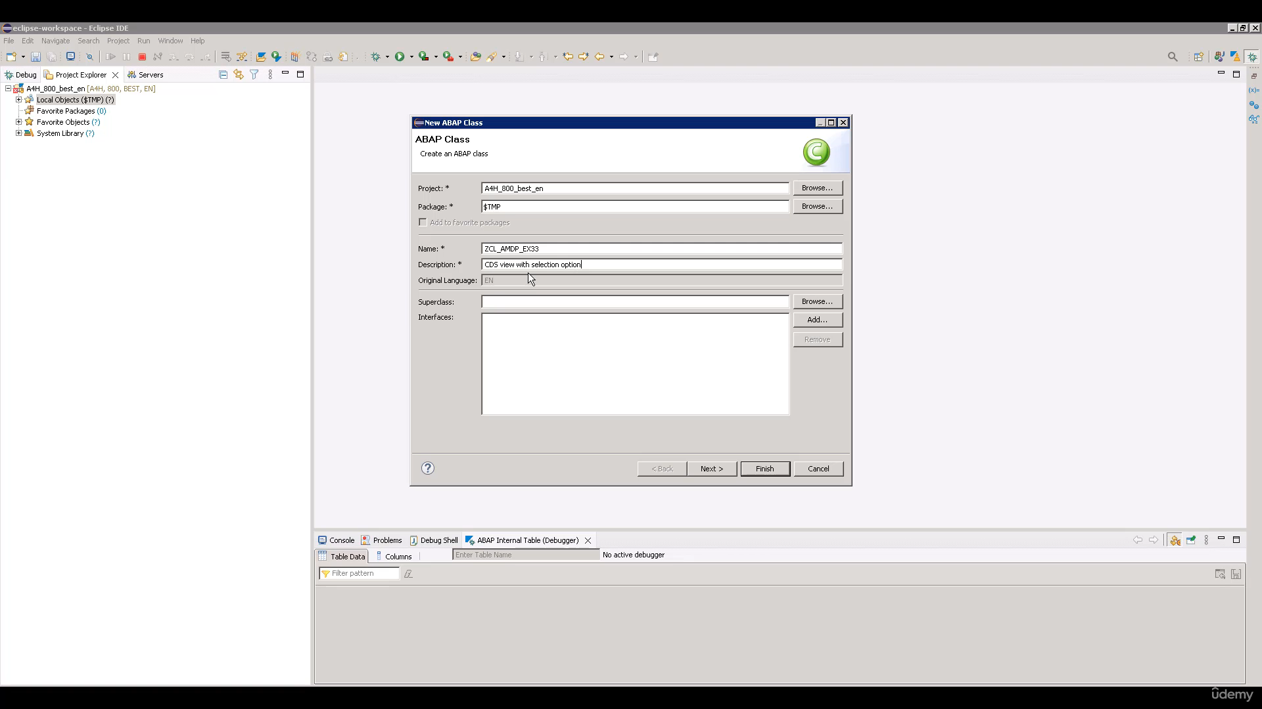

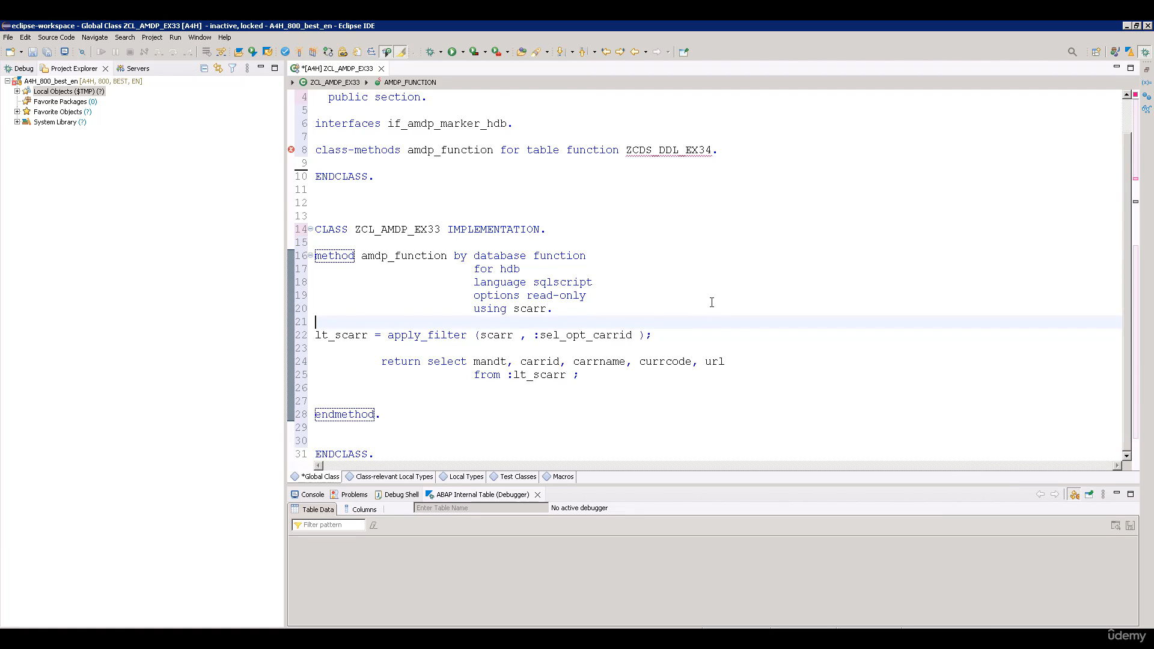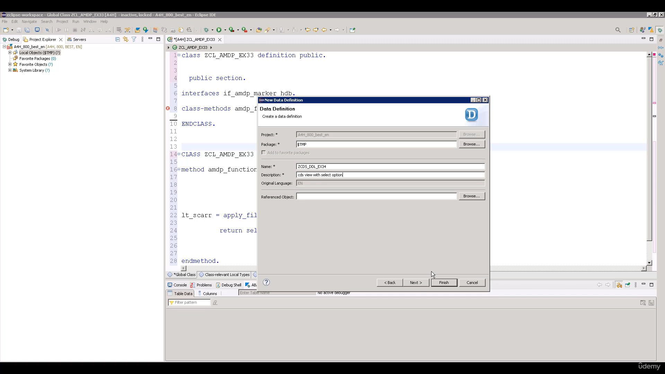

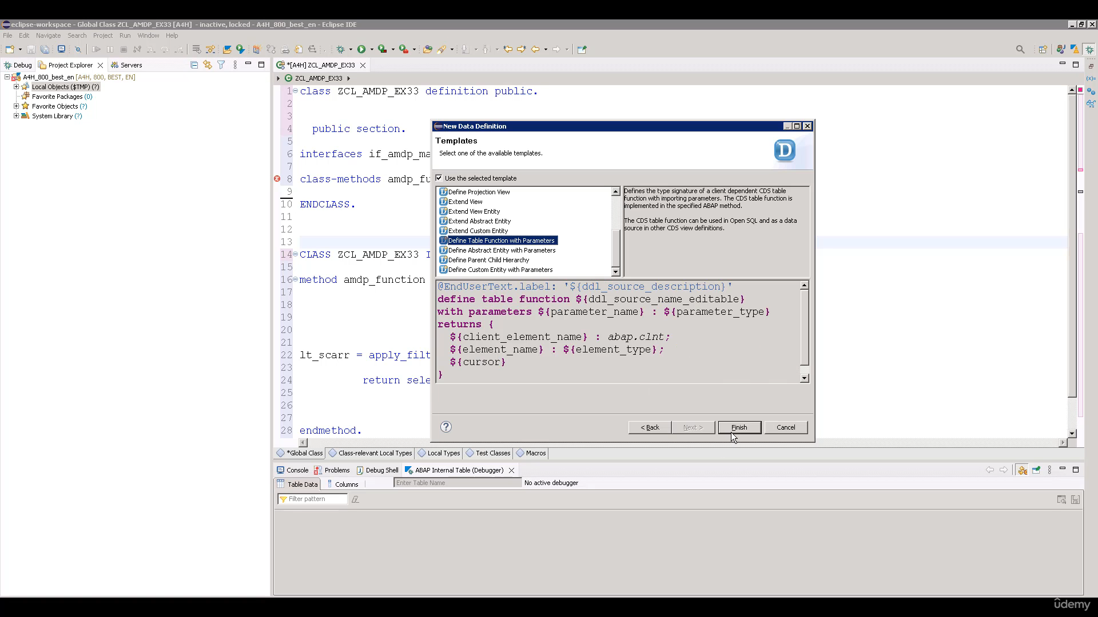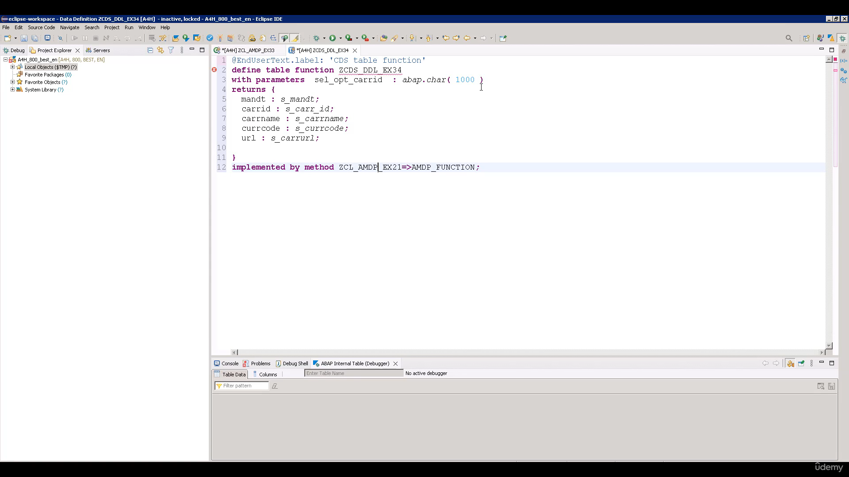

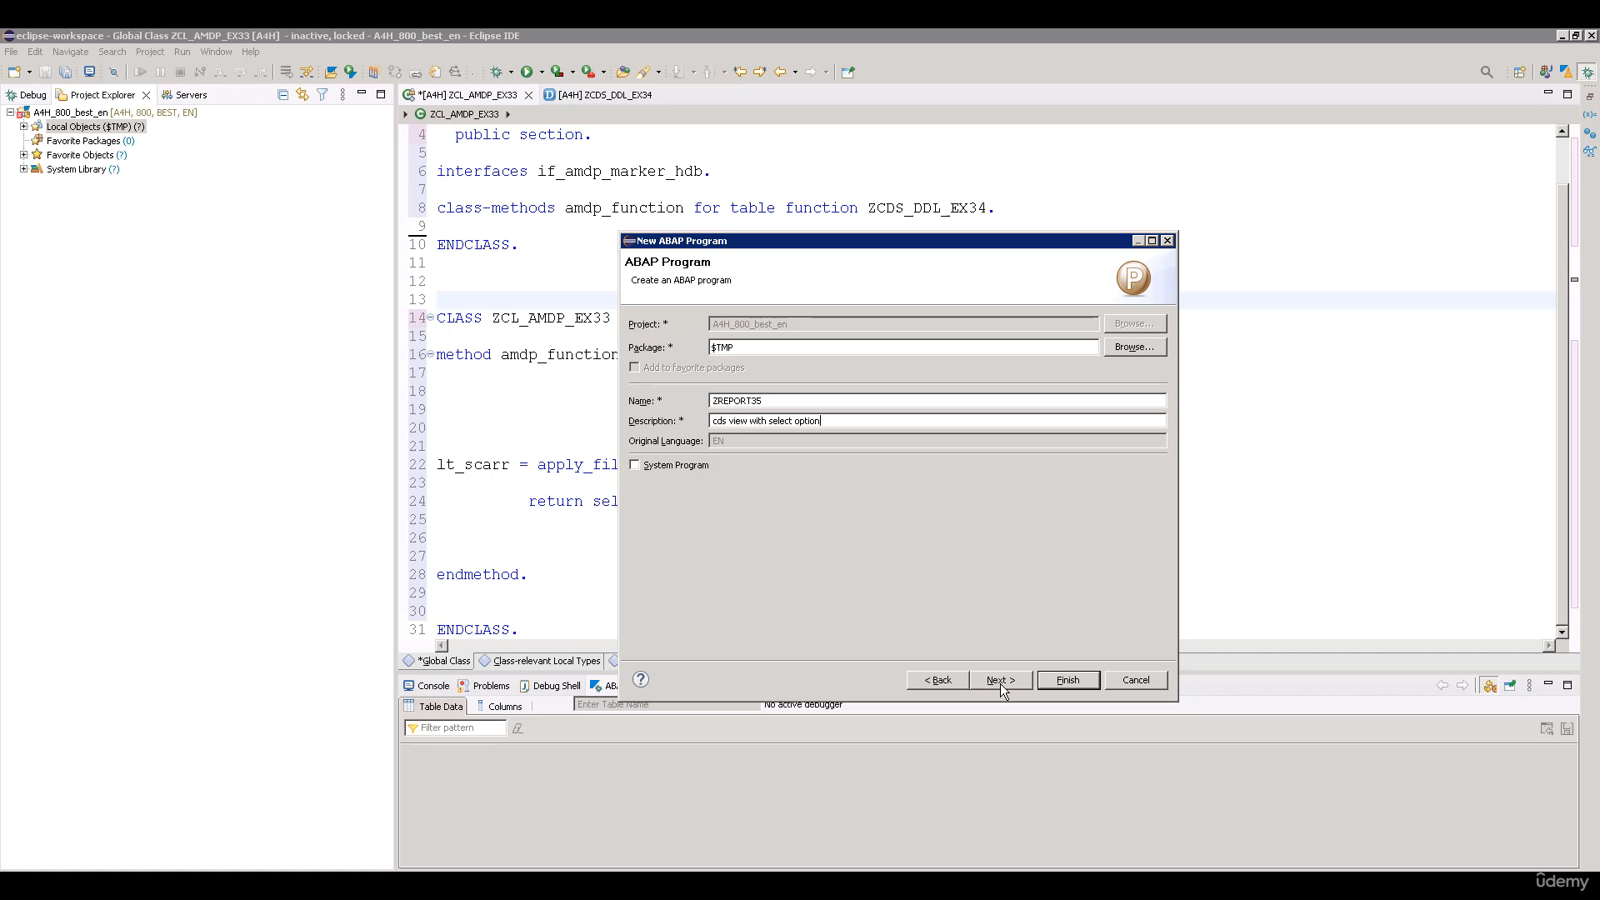

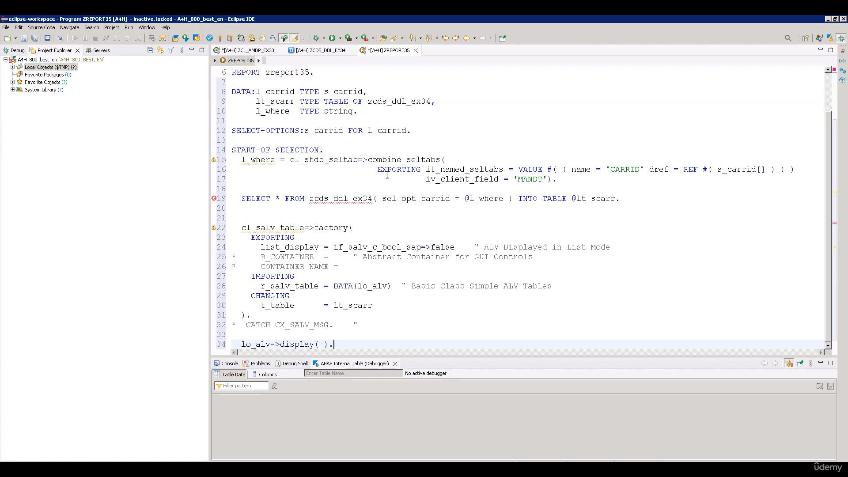

Hi, welcome back.

And this video tutorial, we will see how do you select options with serious views?

When you watching this video, I'm assuming that you have gone to videos related to basic soap IMDb,

how to create and how to consume it in about people and how you can use select options with IMDb.

Again, in this video as well, to save your time, we have provided you three simple examples that

will help you create solace with table function, MLP function method and the above report tokens in

the studio through.

OK, so let's start.

This was great when MTBE glass.

Let's give it a name as to see they're still MBP example.

33.

Let's give a description as soon as we have it.

Select option.

OK, so you will get the basic template of definition and implementation since you already have code

with us.

We will simply copy paste that code.

OK, so here we are, creating one an MVP function for studio through their studios.

Digital example.

Thirty four.

An implementation part we are implementing, method aimed to be functioned as a database function for

online database with language skills group and with using table to see order.

OK, before we proceed further, let's first create serious foods.

Exodus Digital Example 34.

That scrutiny, major cities did example 34 description, a serious view with seduction.

OK, the next.

OK, next.

Now here you can use definition template.

The fine table function with parameters.

So, no, you too many miles away for it again.

We will simply copy the code that we have.

OK, so basically, we're creating here one.

Serious with table function there through this detailed example, thirty four.

With parameter selection clarity, which is of type Abubakr.

This city is filled with terrible French and is implemented with aimed pure function of glass.

They're silly and sleepy.

Example 33.

So no less active in this issue.

Will two MVP class.

In the implementation of employee pension, we are using a blow filter on Table Ciara, and we are passing

very close.

The resultant output is calculated to table a C++.

Then, as you know, whenever we use MBP function, we have to return value using keyword written.

So basically, we are returning.

This flow freely, information from this stable LP is attack.

OK.

Which holds further value from Ciara.

Based on the very close that we have supplied.

No less good when I put.

Let's give it name as.

Surgery 35 description at serious view.

Select option.

No, we will simply copy and paste the code from Russo's file and pasted you.

OK, we are getting one error here.

OK.

We've all got to activate our MBP glass.

When I do this check.

OK, so now that it has gone

so in this above report, we will take input in the form of select options for Kennedy.

Then we were going to word the it's karate Senate option table into one single very close.

Online No.19, we are fetching data from Dirty Digital Example 34

by passing very close to parameter selection guarantee and we are collecting result in two Table 80

ICRA.

This portion of code is there to simply display the content in dinner table or DACA.

OK, so now let's activate this report.

And let's execute.

And it's possible to select option.

And execute.

And here is a low output, so that means our written code is working perfectly fine.

Now, let's set a break point to you.

Then we will set a break point here.

OK, now let's rerun the debate.

The weekly comment period, though, you can see.

Whatever input we help us.

To select option is get converted into one very clustering.

Then Group six to execute this line.

OK, now you can see the control entrance to every perimeter.

There is a six year and double click on LDC at.

So now you can see this table contains these two records, which are fetch from people, Ishihara,

based on the word clustering that will help us, that we hope to get out from select option and then

all the food from this table.

Is returning to M.D. Preferential.

Let's do IP6 now, as you can see again, the control transfer transferred back to the other people.

Now we will simply display the content.

Let's do it.

And you can see it is a low output.

So now I hope you have understood how you can use select options with serious fuel tank of all watching

this video?

Have a nice day.